DEtecTING SATURATED PIXELS AND BLOOMING EFFECTS FROM SATELLITE IMAGES BASED ON IMAGE STATISTICS AND SPATIAL IMAGE QUALITY ANALYSIS

C. Lee¹ and W. Yoon¹, T. Kim*²
¹3DLabs Co. Ltd.,
56 Songdogwahak-ro, Yeonsu-gu, Incheon, Republic of Korea
Email: lch0226, wsyoon@3dlabs.co.kr
² Professor, Dept. Of Geoinformatic Engineering, Inha University,
100 Inha-ro, Michuhol-gu, Incheon, Republic of Korea
Email: tezid@inha.ac.kr

KEY WORDS: Landsat-8, Saturated pixel, Blooming effect, Image statistics, Spatial image quality analysis

ABSTRACT: Identifying saturated and blooming pixels within optical satellite imagery can help users with image interpretation and further processing. Saturation refers to masking pixels that exceed the representable brightness range. This occurs due to sensor calibration issues, high reflectance, shooting altitude, and other factors. Blooming refers to the phenomenon in which an over-charged signal spills over to nearby pixels when saturation occurs in a Charge-Coupled Device (CCD) sensor. Saturation and blooming in satellite imagery can lead to distortion in visibility and pixel information loss. For this reason, earth observation satellite image vendors, such as Planet, provide users with a saturation mask within Unusable Data Mask (UDM). However, this data does not simultaneously detect the presence of blooming objects. In this study, we propose a method for detecting saturation and blooming in medium-resolution satellite imagery based on image statistics and edge response. We used two Landsat-8 OLI Images, which provided a location of saturated pixels in Quality Assessment (QA) mask data. For Saturated pixel detection, we considered QA mask as ground truth and compared our detection results quantitatively and qualitatively. For blooming effect detection, we choose blooming areas manually and evaluate our results. In conclusion, saturation mask exhibited an average accuracy of 84% when compared to the QA mask. In the manually selected blooming regions, our method demonstrated a detection accuracy of 100%.

1. INTRODUCTION

In remote sensing for Earth observation, particularly Charge-Coupled Device (CCD) sensor detects bright objects, saturation and blooming can occur. Saturation refers to masking pixels that exceed the representable brightness range. This occurs due to sensor calibration issues, high reflectance, shooting altitude, and other factors. Blooming refers to the phenomenon in which over-charged signal spills over to neighboring pixels when saturation occurs in a Charge-Coupled Device (CCD) image sensor. Saturation and blooming in satellite imagery can lead to distortion in the visibility and pixel information loss. Therefore, some satellite platforms such as Planet provide users with a saturation mask within Usable Data Masks (UDM). However, this data does not simultaneously detect the presence of blooming object. Furthermore, traditional algorithms for detecting saturation have often utilized basic methodologies, including predefined saturation thresholds or statistical analysis of pixels based on sensor specifications. These methodologies also exhibit limitations with respect to the detection of blooming objects. Therefore, we have developed an algorithm that detects both saturation and blooming in medium to high-resolution satellite imagery. Proposed algorithm detects saturation and blooming in medium to high-resolution satellite imagery, based on image statistics and spatial image quality indicators such as edge response.

2. MATERIALS

In this study, we utilized two images from the Landsat-8 OLI. The images have a resolution of 15m and consist of nine bands: coastal aerosol, blue, green, red, near infrared, shortwave infrared 1 and 2, panchromatic, and cirrus. The processing level corresponds to Level-1 Terrain Corrected Processing (L1TP), in which terrain distortion has been corrected using the satellite's orbital and angular information. Blooming regions typically appear in brightly lit urban areas. Therefore, we selected the blooming regions from two images of New York and Amsterdam, acquired during the spring season. The chosen blooming areas are illustrated in Figure 1.

Amsterdam, Netherlands | Site #1 | Site #2 | Site #3
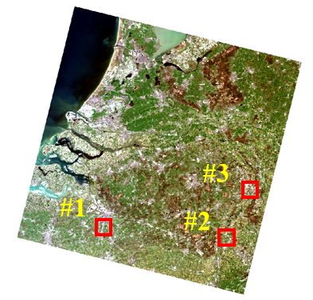
New York, United States | Site #1 | Site #2 | Site #3
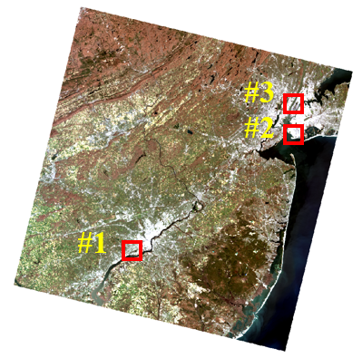 |  |  | 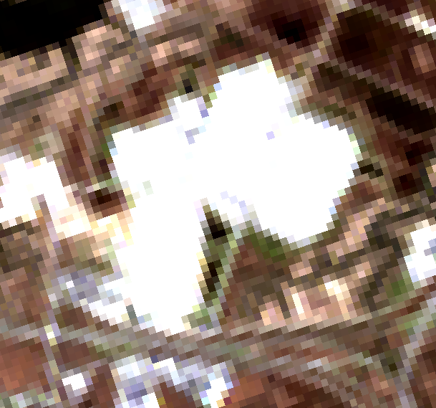
 |  |  | 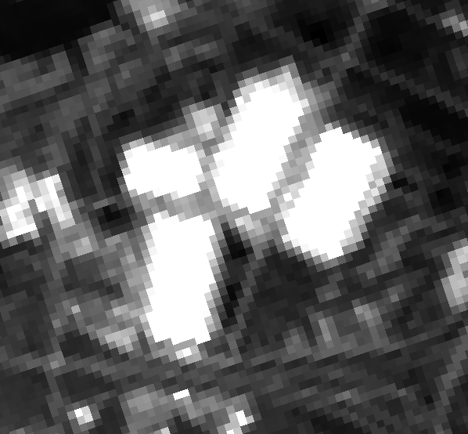
Figure 1. Experimental Landsat-8 OLI R-G-B merged images used for detection saturation and blooming pixel.
Blue band image also included to identify blooming area.

3. METHODOLOGY

The proposed algorithm follows four processes: image preprocessing, saturation pixel detection, edge pixel detection, and blooming detection. Initially, experimental images provided in the DN domain are converted to the radiance domain using the radiometric scale factor included in the Landsat product metadata. This preprocessing step is crucial for applying the threshold values provided in the radiance domain (Ron et al., 2015). After applying thresholds to each band and consolidating the outcomes, an initial saturation mask is formed. Following that, the Canny edge detection algorithm is applied to detect edge pixels within the initial saturation mask. (Canny et al., 1986). Since blooming phenomena occur only around saturated pixels, the newly generated edge map is segmented into individual objects to investigate the presence of saturated pixels within those regions. If no saturated pixels are found within an edge map object, then that object is not an edge pixel detected near a saturated pixel, so it is disregarded. Subsequently, considering the directionality of the pixels identified as edges, the responsiveness of the edge pixels is determined. Afterward, A threshold is applied to the newly created edge response map to generate the final blooming map.

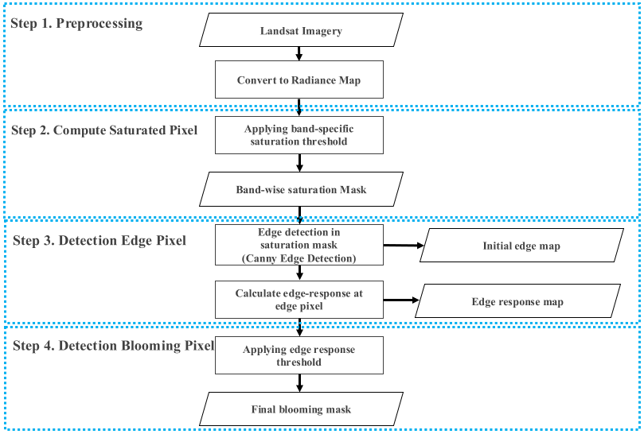
Figure 2. Flowchart of purpose method.

3.1 Data Preprocessing

Radiance domain is the range or context within which these brightness values, often in units of watts per square meter per steradian, are interpreted in remote sensing analysis. To apply the band-specific saturation thresholds proposed in a previous study (Ron et al., 2015), it is necessary to convert the DN domain of the Landsat-8 OLI product to the Radiance domain. The formula outlined below delineates the conversion process from the DN domain to the Radiance domain. This process is applied to each pixel of the experimental images. To convert from DN to Radiance is shown in Equation (1).

$L_{λ}= M_{L}Q_{cal}+A_{L}$ (1)

where $L_{λ}$ = TOA spectral radiance (Watts/($m^{2}$ * srad * $μ$m))
$M_{L}$ = Band-specific multiplicative rescaling factor from the metadata (RADIANCE_MULT_BAND_x,
where x is the band number)
$A_{L}$ = Band-specific additive rescaling factor from the metadata (RADIANCE_ADD_BAND_x,
where x is the band number)
$Q_{cal}$ = Quantized and calibrated standard product pixel values (DN)

3.2 Detection of saturated pixels

The Landsat-8 OLI product defines saturation values in the Radiance domain for each band (Ron et al., 2015). The phenomenon of saturation frequently manifests within the visible light spectrum as well as the near-infrared wavelengths. Consequently, saturation radiance thresholds were applied to the Blue, Green, Red, and NIR bands, generating saturation masks for each band. In this study, these saturation masks were combined to form an initial mask. The radiance saturation threshold values for each band are as presented in the Table 1. below.

Blue | Green | Red | Near-Infrared (NIR)
581 | 544 | 462 | 281
Table 1. Band-specific radiance saturation threshold ($W/m^{2}srμ$m)

3.3 Edge detection in saturated object

Initially, a 5x5 dilation filter is applied to the generated saturation mask for the purpose of detecting areas of spread based on the saturation mask. Subsequently, We apply the Canny edge detection algorithm(Canny et al., 1986) to the generated dilation mask to produce an initial edge map. This algorithm operates through four distinct steps. Initially, Gaussian Smoothing is applied to effectively eliminate noise from the input image. This process entails the utilization of a Gaussian filter to impart smoothness to the image, thereby mitigating noise. Subsequently, Image Gradient Computation is conducted to determine the gradients (slopes) of the image for the purpose of edge detection. This computation assists in ascertaining the rate of brightness change at each pixel. Afterward, gradient direction and Magnitude are computed, providing information on both the direction and intensity of the most pronounced change in pixel intensity. Finally, Edge Detection, implemented through Non-maximum Suppression, involves the removal of non-edge pixels and the suppression of pixels that, while not strictly edges, exist in close proximity to edges. This process results in the generation of thinner edges, each with a single-pixel width. Following these procedures, we segment the edge map by object. If there are no saturated pixels within the separated individual object, that object is not considered a blooming object. In conclusion, only blooming objects are selected, and their edges are detected.

3.4 Segment edge map by object

An initial edge map is segmented by object, and the presence of saturated pixels within that object is investigated. Since the blooming phenomenon only occurs around saturated objects, this process serves to detect objects with bright edges that are not associated with blooming pixels. If the object-based segmented edge map contains saturated pixels, the edge response of object is examined. In the opposite case, it is excluded from the investigation.

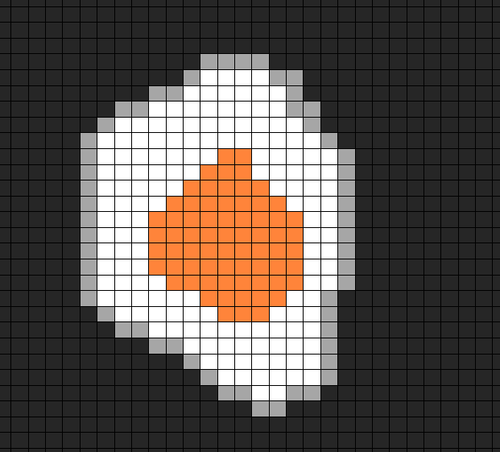 | 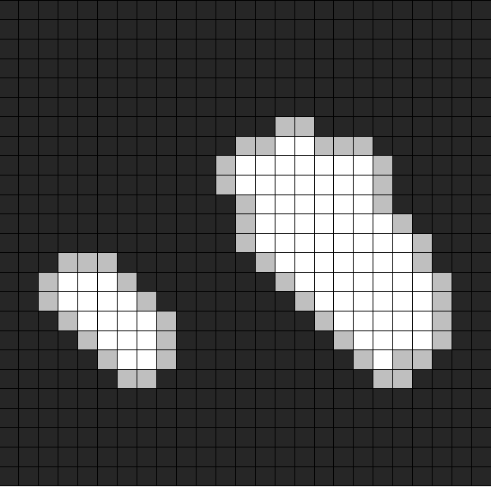 | 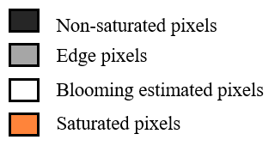
(a) | (b)
Figure 3. Example of blooming and non-blooming object
- blooming object, (b) non- blooming object
3.5 Compute edge response

The proposed algorithm calculates the directional vector between neighboring edge pixels in the object-segmented edge map to determine the response of edge pixels. It measures the average DN Value for 5 pixels inward and 5 pixels outward in a direction perpendicular to the directional vector. Subsequently, the difference between the averages of the inner pixels and the outer pixels is applied to each edge pixel to generate a new edge response map. Finally, the generated map is normalized to analyze the edge responsiveness among blooming objects. The formula for determining edge response is as presented in Equation (2) below.

Figure 4. Workflow for computing pixel response at the edge pixel

$ER\left(P_{\left(x,y\right)}\right)=\left|IER(P_{\left(x,y\right)}) - OER(P_{(x,y)})\right|$ (2)

where $ER\left(P_{\left(x,y\right)}\right)$ = Edge response target pixel
$LER(P_{\left(x,y\right)})$ = Inner edge response target edge pixel
$OER(P_{(x,y)})$ = Outer edge response target edge pixel

In the given equation, IER($P_{\left(x,y\right)}$) represents the Inner Edge Response at the edge pixel, specifically within the blooming region. The IER is defined as the average of the pixel values DN($P_{\left(x,y\right)}$) for the five pixels inside the blooming region, moving inwards from the reference edge pixel. During this calculation, the directionality with the previous edge pixel is taken into account. Similarly, the same operation is performed for the outer region relative to the edge. The final ER($P_{\left(x,y\right)}$) at the reference edge pixel is defined as the absolute difference between IER($P_{\left(x,y\right)}$) and OER($P_{\left(x,y\right)}$). In this case, the edge pixels are stored sequentially by object. As the order of pixel storage indicates direction, the directional vector(Equation 3) between an edge pixel detected in an object and the next edge pixel can be determined through the difference in coordinates. To calculate the DN value of the pixel in a direction perpendicular to the derived directional vector, Equations (4) and (5) below can be utilized to determine the directional orientation of the pixels that need to be examined.

$Direction Vector\left(P_{1},P_{2}\right)=\left[\begin{matrix}x_{2}-x_{1} \\ y_{2}-y_{1}\end{matrix}\right]$ (3)

$Perpendicular Vector\left(D_{inner}\right)=\left[\begin{matrix}-(y_{2}-y_{1}) \\ x_{2}-x_{1}\end{matrix}\right]$ (4)

$Perpendicular Vector\left(D_{outer}\right)=\left[\begin{matrix}y_{2}-y_{1} \\ -(x_{2}-x_{1})\end{matrix}\right]$ (5)

where $P_{1}$ = target edge pixel in Blooming contour
$P_{2}$ = next edge pixel in Blooming contour
$Perpendicular Vector\left(D_{inner}\right)$ = Direction vector pointing inwards(blooming area)
$Perpendicular Vector\left(D_{outer}\right)$ = Direction vector pointing outwards(non-blooming area)

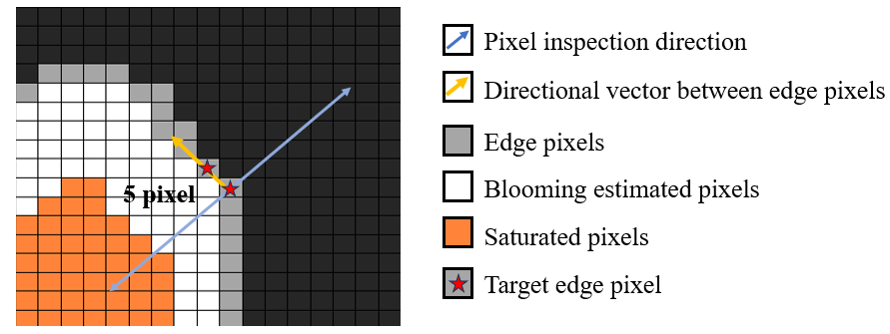
Figure 5. Edge response measurement method considering the directionality between edge pixels

3.6 Analyzing edge response difference saturated object between non-saturated object

The edge response threshold was set on the normalized Edge response map to generate the final blooming map. The edge response of bright objects that do not contain saturation pixels was analyzed in comparison to the edge response of blooming objects containing saturation pixels. The edge response in blooming objects containing saturation pixels appeared significantly higher than in the control group without them. In this study, the meaningful boundary for the threshold was chosen as the average minus the standard deviation for the blooming objects and the average plus the standard deviation for the non-blooming objects.

 | 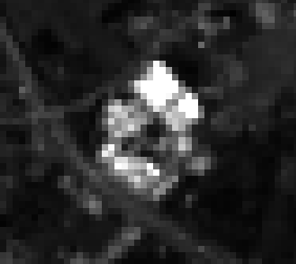
(a) | (b)
Figure 6. Blooming object and non-blooming object example
- Blooming object, (b) non-bloomin object
Object type | Non-blooming object  (standard deviation + average) | Blooming object  (standard deveiation – average)
Edge response value | 0.11668 | 0.13242
Final threshold | 0.12
Table 2. Edge response threshold based on object edge response statistics
4. RESULTS

Initial saturation mask and the blooming mask generated using the proposed algorithm were analyzed both qualitatively and quantitatively. Saturation mask created using the Blue, Red, Green, and NIR bands showed an accuracy of over 84% when compared to the saturation mask provided as a product by Landsat. Visual analysis was performed in the actual blooming areas using the blooming mask generated with the proposed algorithm. Objects in which pixels exceeding the final edge response threshold made up more than 50% were identified as blooming objects, and these objects had their internal pixels filled in and were included in the final blooming mask.

4.1 Saturation mask accuracy assessment

We conducted an evaluation of the accuracy on our test outcomes. The resultant binary mask is characterized by values of 0 (non-Saturated) and 1 (Saturated). To assess the efficacy of our detection, we computed standard metrics like Recall, Precision, F1-score, and Accuracy, typically employed for the assessment of classification and detection frameworks using the confusion matrix. The corresponding formulas are presented in Equations 6, 7, 8, and 9.

$$Recall= \frac{True Positive}{True Positive+False Negative}\text{ (6)}$$

$$Precision= \frac{True Positive}{True Positive+False Positive}\text{ (7)}$$

$$F1-Score= \frac{2×Precision×Recall}{Precision+Recall}\text{ (8}\text{)}$$

$$Accuracy= \frac{True Positive+True Negative}{True Positive+False Positive+True Negative+False Negative}\text{ (9}\text{)}$$

4.2 Saturation detection

An initial saturation mask was generated by integrating saturation masks for each band. The quality metrics of this initial saturation mask were assessed based on the saturation mask provided by Landsat as a reference. Metrics evaluated were Recall, Precision, F-1 Score, and Accuracy, with the results presented in Table 3 below. The reason for the average recall and F1-score of the saturation mask from the proposed algorithm being around the 70% range is likely because the Landsat product uses various bands beyond visible light to provide bit masks for each band. In contrast, our study only utilized the Blue, Green, Red, and NIR bands to generate the initial mask. This indicates that the classification with respect to the true values might be slightly inferior compared to the Landsat saturation mask. However, the saturation mask produced in this study detects pixels that are clearly saturated in the visible and near-infrared wavelengths. Therefore, when compared to the Landsat mask, the precision registered at 84%, and the accuracy was a notable 100%. The quantitative metrics of the saturation mask obtained from our research are presented in Table 3.

Site #1 | 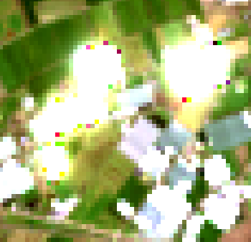
 | (a) | (b) | (c)
Site #2
 | (a) | (b) | (c)
Site #3
 | (a) | (b) | (c)
Figure 7. Comparison between the Landsat saturation mask and the derived saturation mask
- R-G-B merged image (b) Landsat saturation mask (c) Initial saturation mask

Recall(%) | Precision(%) | f-1 score(%) | Accuracy(%)
72 | 84.1 | 76.7 | 100
Table 3. Accuracy assessment results of the generated initial saturation mask

4.3 Blooming detection

For blooming detection, we first selected a subset area from each image where blooming appeared. Final blooming mask for that area was visually analyzed to evaluate its accuracy. When applying the proposed algorithm to areas displaying light scattering effects rather than just simple saturation, it was observed, as shown in Figure 7, that a broader area was detected as blooming pixels compared to the saturated pixel regions. Final blooming mask appears expanded compared to the saturation pixel mask, as the core saturated pixels within influence the surrounding pixels, as illustrated in the Figure 8. (c). For the images from the Netherlands and New York, blooming detection was carried out on 9 and 4 blooming regions respectively. We qualitatively confirmed that blooming was well-detected in the designated area, as depicted in the Figure 8. below.

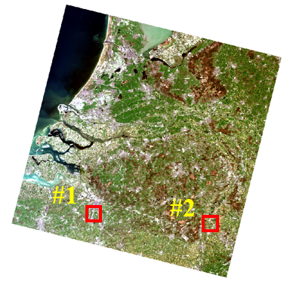 | Site #1 | 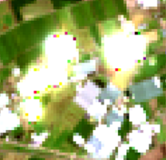
 |  | (a) | (b) | (c)
 | Site #2
Neverlands |  | (a) | (b) | (c)
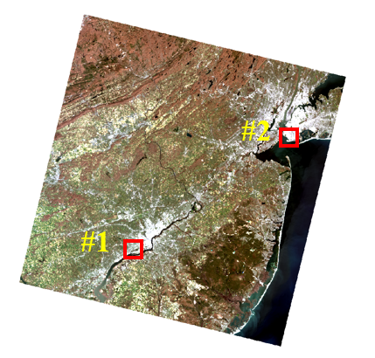 | Site #1
 |  | (a) | (b) | (c)
 | Site #2
New York |  | (a) | (b) | (c)
Figure 8. Results of blooming detection using the proposed algorithm.
- R-G-B merged image, (b) Blue-band image, (c) Blooming mask

5. CONCLUSIONS

This study investigated the potential for detecting saturation and blooming phenomena in high-resolution images caused by the saturation of CCD sensors, utilizing the reactivity at pixel edges. The evidence obtained from both quantitative and qualitative evaluations emphasizes the effectiveness of detecting blooming objects in images by harnessing the reactivity of edge pixels. Our findings revealed a significant difference in edge reactivity for blooming objects occurring around saturated pixels compared to merely bright objects that are not saturated. This confirmed that the blooming phenomenon only manifests around saturated pixels. However, a limitation of our study was the small sample size of experimental images in which the blooming phenomenon occurred, possibly reducing the reliability of the edge threshold values used to differentiate between blooming and non-blooming objects in the edge map. For future research, we plan to enhance the reliability of threshold determination within the edge map by increasing the sample size of the experimental images. Furthermore, within the saturated mask, we also consider the utilization of the watershed method instead of the dilation filter to identify the initial blooming areas.

ACKNOWLEDGEMENTS

This study was conducted as part of the task of the Korea Forest Service’s Nation Institute of Forest Science, “Reception, Processing, ARD Standardization, and Development of Intelligent Forest Information Platform (task number: FM0103-2021-01)

REFERENCES

Amirhossein Rostami, Reza Shah-Hosseini, Shabnam Asgari, Arastou Zarei, Mohammad Aghdami and Saeid Homayouni, 2022, Active Fire Detection from Landsat-8 Imagery Using Deep Multiple Kernel Learning, Remote sensing, 14-992.

Calvin Chao, Kuo-Yu Chou, Charles Liu, Yi-Che Chen, Hon-Yi h Tu, Hsiu-Yu Cheng, Fu-Lung Hsueh, and Shou-Gwo Wuu, 2013, Blooming and antiblooming in 1.1um-pixel CIS, in Proc. IEEE Int. Image Sensor Workshop, Snowbird, UT, USA, pp. 5–8.

Canny, J, 1986, A computational approach to edge detection. IEEE Transactions on Pattern Analysis and Machine Intelligence, PAMI-8(6), 679-698.

Grant Soehnel and Anthony Tanbakuchi, 2012, Simulation and experimental characterization of the point spread function, pixel saturation, and blooming of a mercury cadmium telluride focal plane array, applied optics, 51-33.

Nana Akahane, Satoru Adachi, Koichi Mizobuchi,and Shigetoshi Sugawa, 2009, Optimum Design of Conversion Gain and Full Well Capacity in CMOS Image Sensor With Lateral Overﬂow Integration Capacitor, IEEE TRANSACTIONS ON ELECTRON DEVICES, 56-11.

Ron Morﬁtt, Julia Barsi, Raviv Levy, Brian Markham, Esad Micijevic, 2015, Landsat-8 Operational Land Imager (OLI) Radiometric Performance On-Orbit. Remote sensing, 2208-2237.

Xin Caoa, Yang Hua, Xiaolin Zhub,⁎, Feng Shic, Li Zhuod, Jin Chena, 2019, A simple self-adjusting model for correcting theblooming effects in DMSP-OLS nighttime light images.Remote sensing of Environment, 401-411

